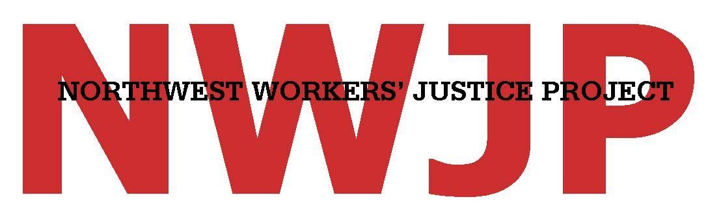

FOURTH ANNUAL CELEBRATION OF WORKER JUSTICE
Friday, June 3, 2016 5:30 p.m. to 9:00 p.m.
The Eliot Center
Portland, Oregon
Event Sponsorship Levels and Benefits
Sponsorship Level | Amount | Benefits
Friend of Fairness | $250 | - Two event tickets;  - Two drink tickets;  - Public acknowledgment.
Champion of Change | $500 | - Four event tickets;  - Four drink tickets;  - 1/8 page recognition in program.
Defender of Dignity | $1,000 | - Six event tickets (reserved seats);  - Six drink tickets;  - 1/4 page recognition in program.
Guardian of Justice | $2,500 | - Reserved table (eight tickets);  - Eight drink tickets;  - 1/2 page recognition in program.
Workplace Warrior | $5,000 | - Reserved table (eight tickets);  - Eight drink tickets;  - Full-page recognition in program.

You may register as a sponsor online at nwjp.org/2016-event-sponsorship or by completing and returning this form.

Yes! We want to sponsor this event and be recognized as a:

Friend of Fairness ($250) Guardian of Justice ($2,500)
Champion of Change ($500) Workplace Warrior ($5,000)
Defender of Dignity ($1,000)

Name(s) of Sponsor(s):
E-mail:
Phone:
Street Address:
City / State / ZIP:

MY SPONSORSHIP GOES TO (please select one):
NEED Fund, a 501(c)(3) nonprofit (sponsorship is tax-deductible).
NWJP, a 501(c)(4) nonprofit (sponsorship is NOT tax-deductible).

To pay for your sponsorship by check, please make payable to either NWJP or NEED Fund
and send to NWJP at the address below.

Anything else we should know?

Please return this form no later than Friday, May 20, 2016 to:
812 SW Washington Street, Suite 225
Portland, OR 97205
Fax: 503-946-3029 E-mail: lindsay@nwjp.org

